Belts
When a belt slides on a surface, the friction between the belt and the surface makes the tension in the belt change. If the belt is sliding on a cylindrical surface, the tension will depend on the contact angle and the coefficient of friction between the belt and the cylinder.
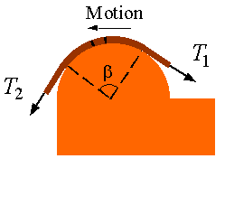
To show this we can draw the free body diagram of a segment of the belt
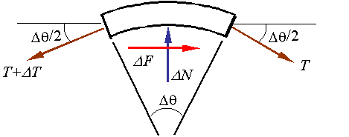

The equilibrium equations for this segment are
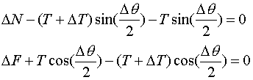
Substitution of , using the small angle approximations, and taking a limit yields
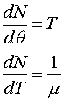

Combining the two equations to eliminate N yields
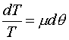
Integrating this over the interval of contact yields
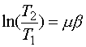
The relation between tension on one side of the contact and on the other side can be then calculated from the equation
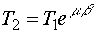
where is the contact angle in radians and is the coefficient of friction.

