Statics-Sample Exam II
Note to the students: The following is a typical "Exam II" for statics. It should give you an idea of the difficulty of the exam. Try to do the exam in 50 minutes without the aid of your book or your notes, only using your one page of equations (no solutions to problems). For each problem, first layout the procedure to obtain the desired solution, then complete the problem by doing all the details. Don't forget to draw free-body diagrams for the equilibrium problems, and to present your result in three significant digits with proper units. If the figures are not clear, you can find them in the book.
Problem 1: The column is used to support the floor which exerts a force of 3000 lb on the top of the column. The effect of the soil pressure along its side is distributed as shown. Replace this loading by an equivalent resultant force and specify where it acts along the column, measured from the base A.
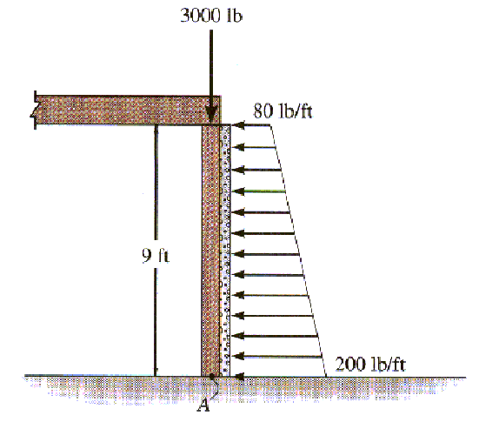
Problem 2: The wall footing is used to support the column load of 12,000 lb. Determine the intensities w₁ and w₂ of the distributed loading acting on the base of the footing for equilibrium.
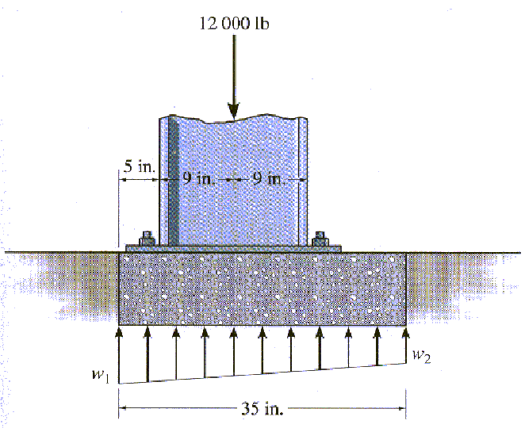
Problem 3: the pipe assembly supports the vertical loads shown. Determin the components of reaction at the ball-and-socket joint A and the tension in the supporting cables BC and BD.
