Equivalent force systems: The wrench
A wrench: A wrench is a force and couple system in which the force and couple are parallel.
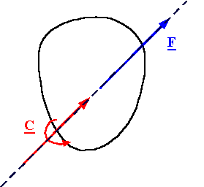
Every force and couple system can be reduced to a wrench: As above, the perpendicular part of the resultant moment can be replaced by sliding the resultant force along the line perpendicular to the plane of the resultant force and resultant couple. What remains after this operation is a wrench which has a moment equal to the component of the resultant couple parallel to the force.
