Moment of a force: Part 2
The cross product: link to math
Moment of Force F around point O: M_{O}
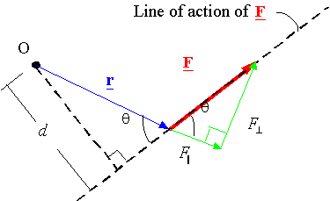
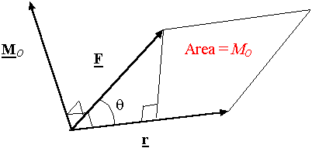
Calculating the moment using rectangular components:
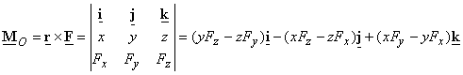
Resultant moment: M_{ro}
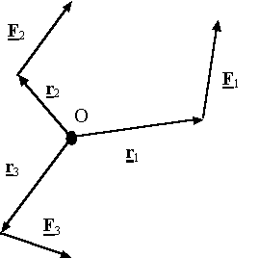
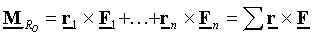
Moment of a force about a specified axis a-a: M_{a}
O: any point on a-a
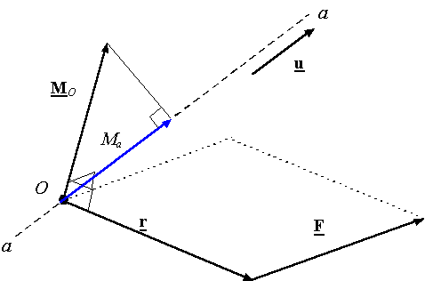
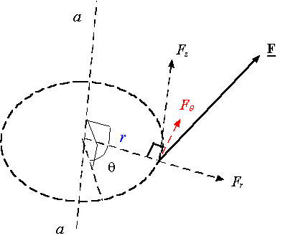
Couple: C
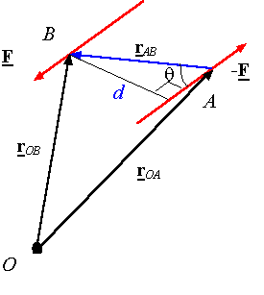
Note: The moment of a couple does not depend on the point one takes the moment about. In other words, a moment of a couple is the same about all points in space.

