Static Equilibrium for a Particle
Objective: To introduce the concept of the free-body diagram for a particle and to show how to solve particle equilibrium problems using the equations of equilibrium.
A particle: An object with inertia (mass) but of negligible dimensions.
A particle at rest: A particle is at rest if originally at rest or has a constant velocity if originally in motion.
Equilibrium equations for a particle: A particle is in equilibrium if the resultant of ALL forces acting on the particle is equal to zero (Newton’s first law is that a body at rest is not subjected to any unbalanced forces).
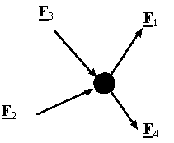
Sum of all forces acting on a particle = 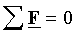
Equilibrium equations in component form: In a rectangular coordinate system the equilibrium equations can be represented by three scalar equations:
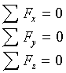
To apply equilibrium equations we must account for all known and unknown forces acting on the particle. The best way to do this is to draw a free-body diagram of the particle.
Free-Body Diagram (FBD): A diagram showing the particle under consideration and all the forces and moments acting on this particle. Each force in this diagram must be labeled (This is a sketch that shows the particle “free” from its surroundings with all the forces acting on it).
String or cable: A mechanical device that can only transmit a tensile force along itself.
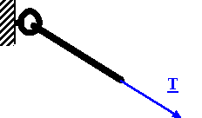
Linear spring: A mechanical device which exerts a force along its line of action and proportional to its extension (F = kX).
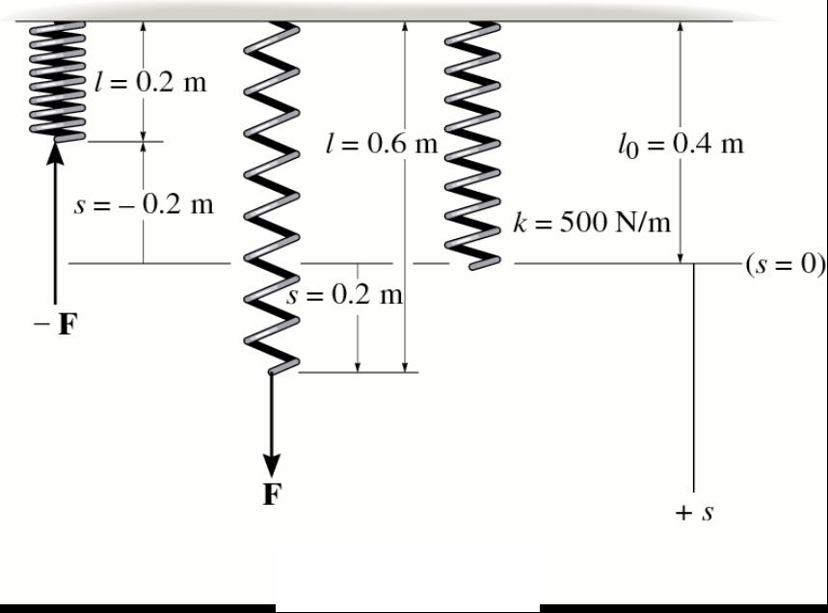
Frictionless pulleys:
Cables are assumed to have negligible weight and they cannot stretch. They can only support tension or pulling (you can’t push on a rope). Pulleys are assumed to be frictionless. A continuous cable passing over a frictionless pulley must have tension force of a constant magnitude. The tension force is always directed in the direction of the cable (For a frictionless pulley in static equilibrium, the tension in the cable is the same on both sides of the pulley).
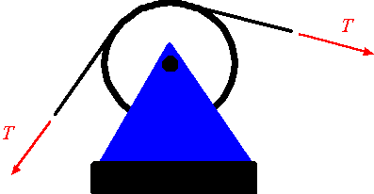
How to draw a Free Body Diagram:
- Draw outlined shape - Imagine the particle isolated or cut “free” from its surroundings
- Show all forces and moments - Include “active forces” and “reactive forces”. Place each force and couple at the point that it is applied.
- Identify each force - Known forces labeled with proper magnitude and direction. Letters used for unknown quantities.
- Add any relevant dimensions onto your picture.

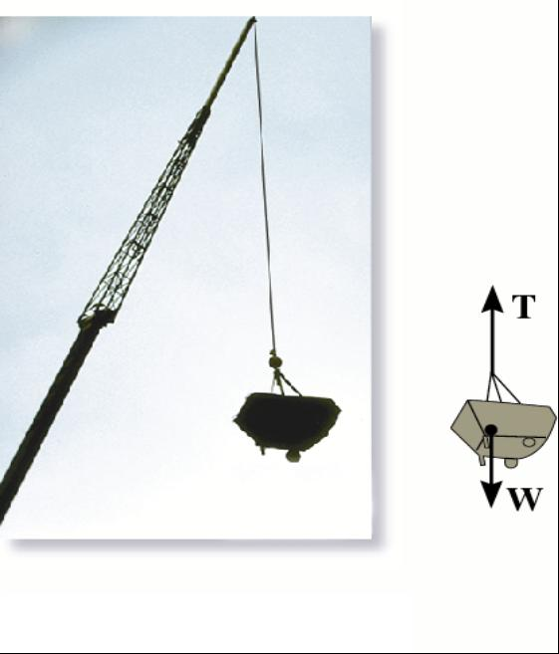

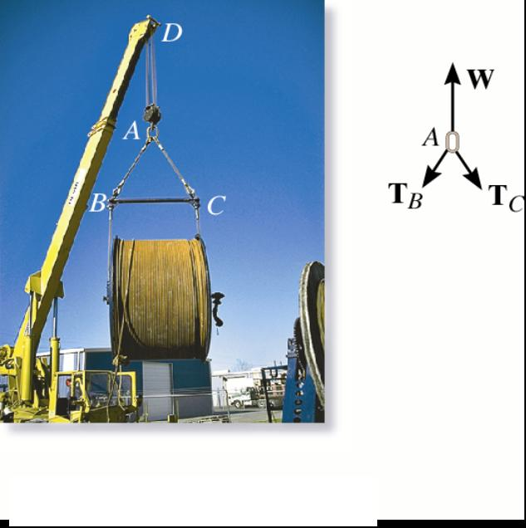

Force types:
Active Forces - tend to set the particle in motion.
Reactive Forces - result from constraints or supports and tend to prevent motion.

