Test 5:

1. What is the unit vector along the line A-B, if the Cartesian coordinates of point A are (5,0,3) and the Cartesian coordinate of point B are (0,5,5)?
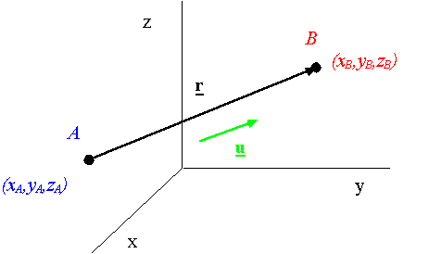
Solution:

