Test 6
3- Draw the FBD of the knots at C and E.
Solution:
Free body diagram at E:  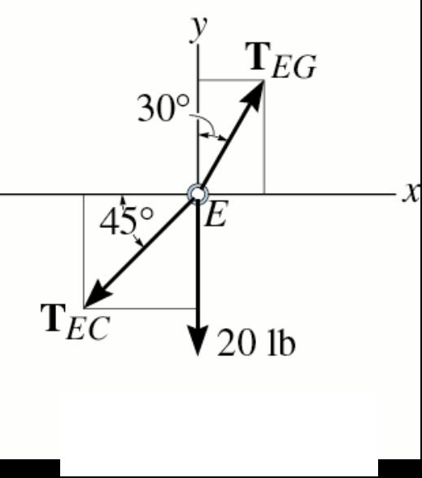 | Free body diagram at C:  