Vectors in three dimensional space
F
F_{x}
F_{y}
i
j
x
y
k
z
F_{z}

This figure shows the Right handed system, which is a coordinate system represented by base vectors which follow the right-hand rule (four fingers from x to y, and thumb will be along z direction).

Base vectors for a rectangular coordinate system: A set of three mutually orthogonal unit vectors

Rectangular component of a Vector: The projections of vector F along the x, y, and z directions are F_{x}, F_{y}, and F_{z}, respectively.
F
F_{x}
i
x
y
z

If the angle between F and its components (F_{x}) on axis
x is α, then
α

F
F_{y}
j
x
y
z

Also, if the angle between F and its components (F_{y}) on axis
y is β, then
β

y

F
Similarly, if the angle between F and its components (F_{z}) on axis
z is γ, then
x
k
F_{z}
γ
cosα, cosβ and cosγ are called: Direction cosines
z
Coordinates of points in space: The triplet (x,y,z) describes the coordinates of a point.

The vector connecting two points: The vector connecting point A to point B is given by
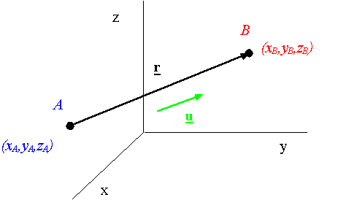

A unit vector along the line A-B: A unit vector along the line A-B is obtained from

