Vectors in 3-D space:

A vector along A-B: A vector F along the line A-B (and of magnitude F) can be obtained from

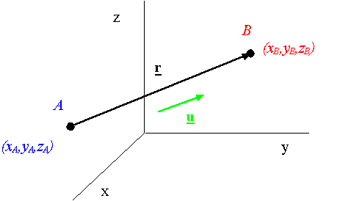

θ
F
E
The dot product: The dot product of vectors F and E is given by

Projection of a vector by using the dot product: The projection of vector F along the unit vector u is given by
F
u
θ

F.u

