Moment of a force: Part 1
The moment of a force about a point is defined as the force magnitude times the perpendicular distance from the point to the line of action of the force. The moment is a measure of the tendency of the force to cause rotation.
Consider the force F acting on the handle of the wrench.
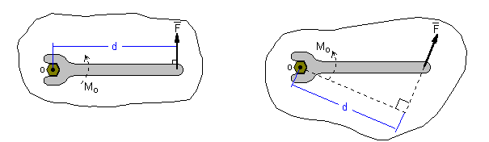
The magnitude of the moment of a force:
M_{O}: Magnitude of the moment of F around point O
d: Perpendicular distance from O to the line of action of F
Direction of the moment in 2-D: The direction of the moment is given by the right hand rule: Counter Clockwise (CCW) is out of the page, Clockwise (CW) is into the page.
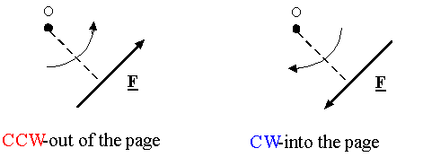
Example: By closing the lid of a bottle, you are imposing a clockwise moment.

Calculating the moment in 2-D using components:
- Select a positive direction (CCW or CW),
- Calculate each moment and add them, using the proper sign for each term,
- Always remember to write the unit of moment which is Nm.

Example:
In the following figure, calculate the moment about the point O:
- We choose the CCW as positive direction for moment,
- Moment of component of F along x about O is Fx times the perpendicular distance from O (or d1), which is clockwise, so it is
- Moment of component of F along y about O is Fy times the perpendicular distance from O (or d2), which is counter clockwise, so it is
- Moments add together as vectors, so the total moment is:
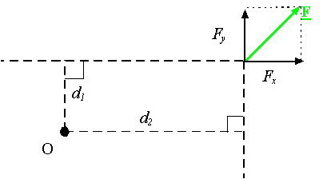
Example:
In the following figure, if θ is 60 degrees and r is 30 mm and F is 6 N, what is the magnitude of the moment about O.
- We choose the CCW as positive direction for moment,
- Component of F along r (or F||) produces no moment, since it passes from point O.
- Component of F perpendicular to r (or )
If a force passes through a point, it produces no moment about that point!
produces the moment .
So the total moment of F about O is:
.
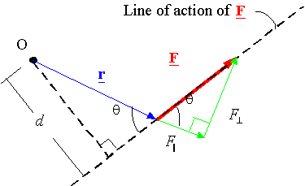
Note: moving a force along its line of action does not change its moment

Remember:
The moment about O is also calculated using the magnitude of force F times perpendicular distance from O to the line of action of F which is d:
.

