Statics

Lessons

Credits for Lecturing and Authoring
Mechanics
Statics and Force
Scalars and Vectors
Force
Resolution of forces into components
A Moment
Free Body Diagram
Inclined Plane
Cable, Rope, or Chain
Roller or Simple Support
Pin or Hinge
Equilibrium
Steps In Solving A Statics Problem
Example #2
Example #3

Mechanics

The study of forces acting on bodies.

3 Branches of Mechanics:

Statics

Dynamics

Strength of Materials

Statics

The study of rigid bodies that are in equilibrium.

Force

A "push" or "pull" exerted by one body on another, such as:
A person pushing on a wall
Gravity pulling on a person

Scalar

A quantity possessing only a magnitude such as mass, length, or time.

Vector

A quantity that has both a magnitude and direction such as velocity or force.

Force

Force is a vector quantity, therefore a force is completely described by:

Magnitude

Direction

Point of Application
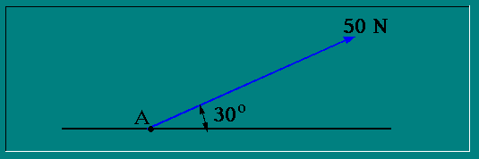

Types of vectors used in statics:
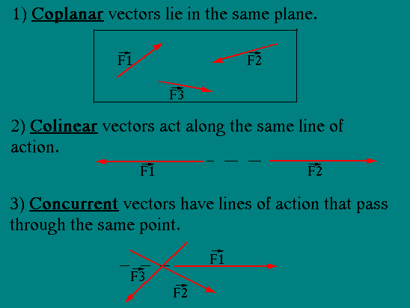

Vector Addition - the parallellogram law.
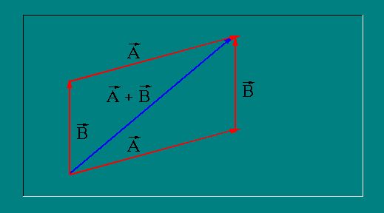

Resolution of forces into components.

The net effect of a number of forces on one point can be the same as the effect of one force.

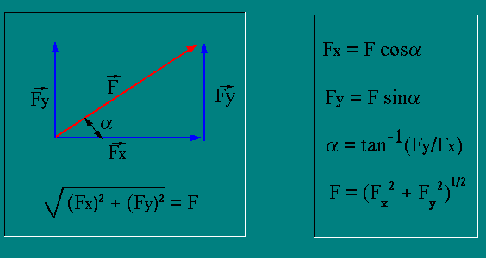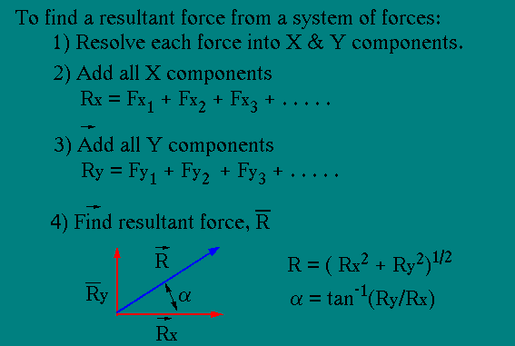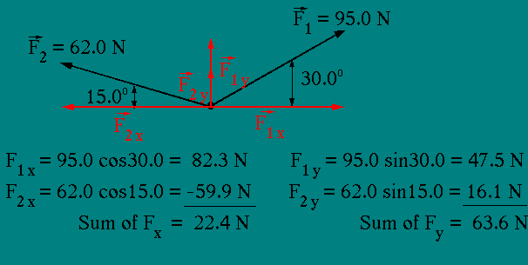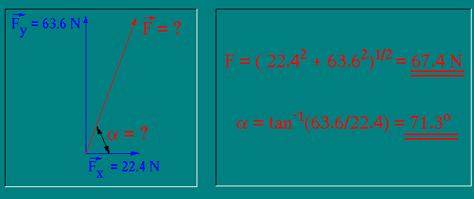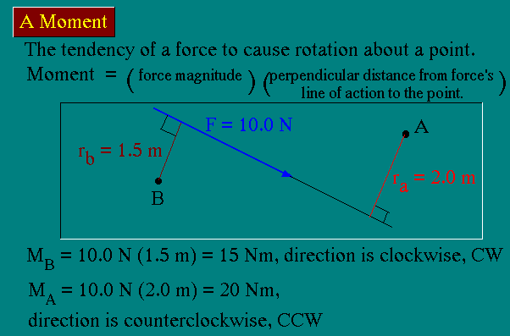

Free Body Diagram

A free body diagram is a sketch of the body and all the forces acting on it.

3 steps in drawing a free body diagram:

Isolate the body, remove all supports and connectors.

Identify all EXTERNAL forces acting on the body.

Make a sketch of the body, showing all forces acting on it.
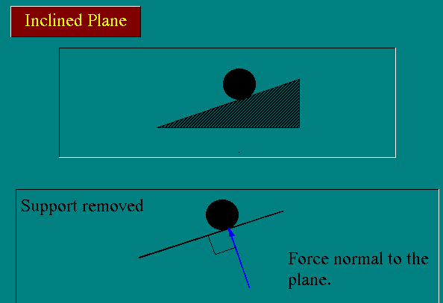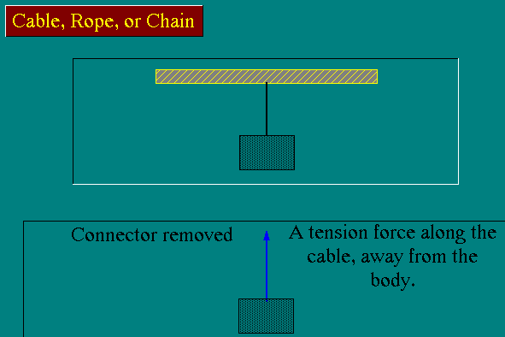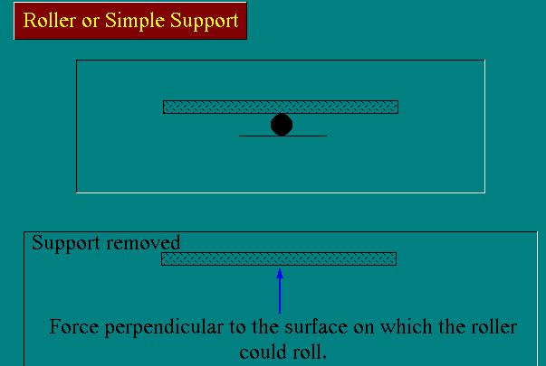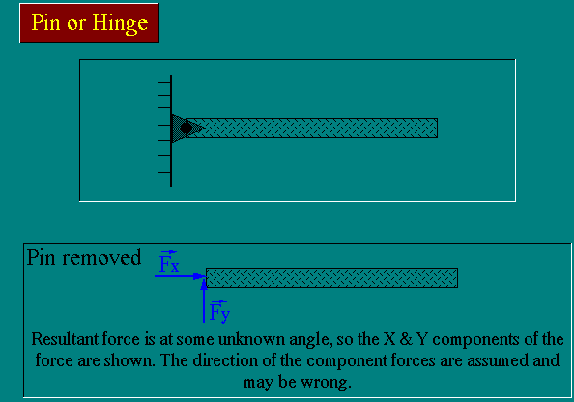

Equilibrium

A body is in equilibrium if the sum of all the external forces and moments acting on the body is zero.
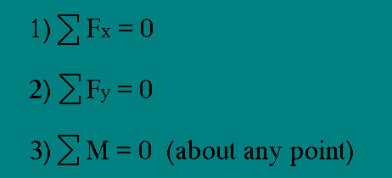

Steps in solving a statics problem.

Draw a free body diagram.

Choose a reference frame. Orient the X & Y axes. (Most often X is chosen in the horizontal direction and Y is chosen in the vertical direction.)

Choose a convenient point to calculate moments around.

Apply the 3 equilibrium equations and solve for the unknowns.

Problem

Two children balance a see-saw in horizontal equilibrium. One weighs 80 pounds, and the other weighs 60 pounds and is sitting 4 ft. from the fulcrum. Find the force the fulcrum applies to the beam and the distance to the fulcrum to the 80 lb. child. (Neglect the mass of the see-saw.)
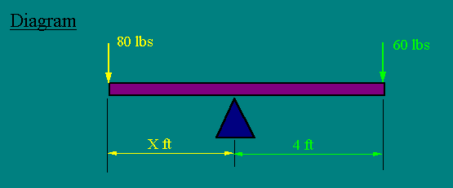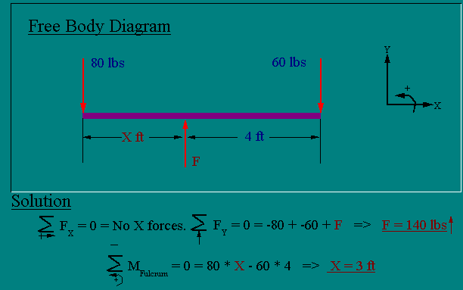

EXAMPLE #2
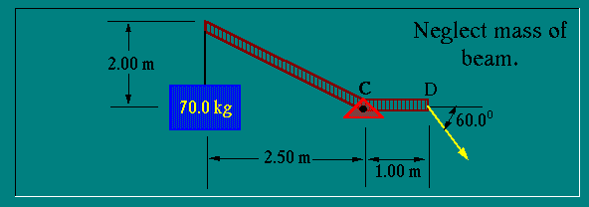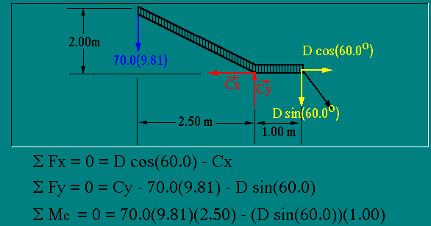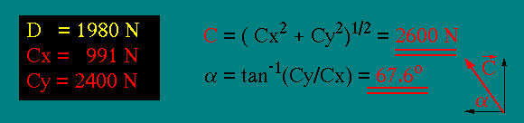

EXAMPLE #3
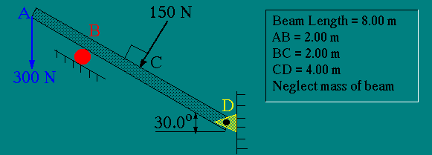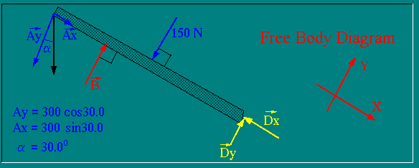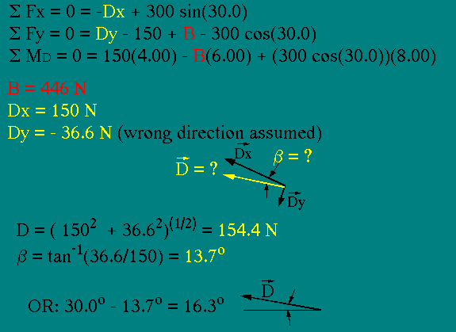
part2:

Chapter 1 : Introduction
1.1 Statics , what is it good for ?
1.2 Types of forces
1.3 Action and Re-action
1.4 What a force can do to a body
1.5 Graphical representation of forces

1.1 Statics , what is it good for ?
NextSec
Let's say you as engineer are presented with all the design details of a certain structure and your task is to make sure that this structure
- does not break under influence of the design load ( that includes a certain safety factor ).
- no material is wasted
Here a structure can be just about anything of interest, the chair you are sitting on, a simple tower for a power line or a bridge over a river.
Often a structure consists of many, sometimes thousands of members (parts) which are connected ( glued , welded, rivetted etc.) to each other. Each individual member is subject to break. So, how do you make sure that none does ?
Well, even if the design is already given to you this task can be difficult enough. It can be roughly broken down into two steps
- Determine the forces acting on each member (this is the EMch 11 stuff ).
- Determine whether the member under consideration can withstand the calculated forces with whatever safety margin is appropriate (this is EMch 13 stuff and things coming after that).
Here is a sample problem, take a peek. If this problem does not make much sense to you now you may want to read Chapter 1 in its entirety first and then come back to it.
TopSec TopChapt NextSec

1.2 Types of forces
PrecSec NextSec
A force is the action of one body onto another. We distinguish :
Contact or support forces
which occur whenever two bodies are in physical contact with each other. They always depend on the details of how the two bodies are connected to each other. You and the chair you are sitting on would be a nice example, your ear being attached to your head and not falling off would be another.
Field Forces
which may be due to gravitation, electro-static,electro-magnetic or nuclear interactions. No contact between the involved bodies is necessary. Actually, the distance between two such bodies can be rather large in comparison to size of the bodies themselves (earth and moon for example).
Warning : Often there are forces of both types acting simultaneously between two bodies.
My example : Take a car sitting outside your house. The car is pulled towards the center of the earth by gravity (we call that force commonly "weight"). This force is constantly present even if the car drives over a hump at high speed and its wheels are not touching the ground momentarily. On the other hand (when the wheels are touching the ground) the earth's surface is pushing upwards onto the car at the points where the wheels and earth's surface are touching. You can think of this force as a kind of resistance force the earth's surface is exerting onto the wheels, trying to prevent (resist) the wheels from penetrating the earth. If the surface is made out of a soft material (like mud or sand) which has not much resistance the car's wheels will actually sink into the ground until enough resistance is encountered.
TopSec TopChapt NextSec

1.3 Action and Re-action
PrecSec NextSec
We just looked at what kind of forces are acting on a car sitting on the ground and argued that the earth exerts not only a gravitational pull onto the car but that the ground is pushing upwards against the wheels of the car.
But what does the car do to the earth ? Well, the contact force is easy, the car is pushing down onto the earth's surface and might even make a dent into it. Obviously, the force the car exerts onto the ground and the force from the ground onto the wheels are in opposite direction (one upwards one downwards in this example).
How about the gravitational force and with that all other field forces ? If I told you that the car is actually pulling the earth towards its own center of mass, you would probably ask me to prove that, wouldn't you ?
Well, let me ask YOU to make up a thought experiment which clearly shows that the gravitational forces between car and earth are oppositely directed. Here is my thought experiment.
Later we will learn that
ALL forces acting between any two bodies come in pairs and are exactly equal in value but exactly opposite in direction. This law is often called Newton's Third Law.
The interaction between different bodies is not always easy to see but is of utmost importance, so here is an example you definitely should have a look at.
TopSec TopChapt NextSec

1.4 What a force can do to a body
PrecSec NextSec
A force acting on a rigid body can in general cause the body to undergo two different types of motion.
- The body starts to accelerate
- The body will start to rotate
Whether the body actually moves/rotates depends on all the forces acting on the given body.
In statics we don't want either to happen and therefore :

Statics : Study of bodies in equilibrium
The demand of bodies neither to translate ( = motion of its center of mass if you will) nor to rotate ( = spinning around its center of mass ) will lead us to different types of equations relating the forces ( in magnitude and direction ) acting on a body to each other. Once we have enough equation we will solve for the unknown forces and we are done with the EMch11-step of the designing process.
TopSec TopChapt NextSec

1.5 Graphical representation of forces
PrecSec
Figure 1.5a
Graphical Representation of Forces
In Figure 1.5a we have three forces acting on the box-like body. Each force is represented by an arrow, pointing in the direction the force is acting and having a length equal to the magnitude of the force. Often the head or the tail of this arrow is placed at the point where the force is acting on the body. This point is then called the point of attachment.
Next to each arrow we have a symbol ( F₁ etc. ) which we use later in equations or inside the text to indicate which of several forces we are talking about. The letters F and subscript 1,2 etc. are completely arbitrary although often used. Other letters which you find in textbooks to represent forces are P, Q, and R.
The arrow above each symbol is a reminder for us that a force is a quantity of a certain value and direction. It is the same notation we use in vector algebra and vector calculus, because as we will shortly see, the physical quantity of a force is as far as mathematical properties are concerned equal to a vector.
NOTE : In Figure 1.5a we do not show the bodies which are exerting the shown forces F₁ etc.
Well, maybe now you'd like to have another peek at the afore mentioned sample problem.
TopSec TopChapt

