Forces and Moments: Part 1
Moment of Force F around point O: M_{O}
The moment of a force about a point or an axis provides a measure of the tendency of the force to cause a body to rotate about the point or axis.

oz ┴ plane xoy in which F_{x} lies
F_{x} causes the pipe to turn about the z-axis F_{x} causes a moment about the z-axis = (Mo)_{z}
F_{y} passes through O
F_{y} does not cause the pipe to turn because the line of action of the force passes through O.
ox ┴ plane zoy in which F_{z} lies
F_{z} causes the pipe to turn about the x-axis
F_{z} causes a moment about the x-axis (Mo)_{x}

Direction of the moment:
The direction of M_{o} would be specified by using the right hand rule.
Counter Clockwise (CCW) is out of the page, Clockwise (CW) is into the page.
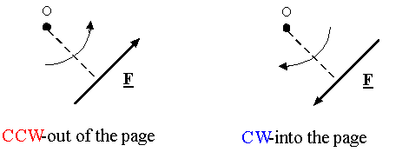
Magnitude of the moment:
|M_{o}|=Fd

Calculating the moment in 2-D using components:
- Select a positive direction (CCW or CW),
- Calculate each moment and add them, using the proper sign for each term,
- Always remember to write the unit of moment which is Nm.

Example:
In the following figure, calculate the moment about the point O:
- We choose the CCW as positive direction for moment,
- Moment of component of F along x about O is Fx times the perpendicular distance from O (or d1), which is clockwise, so it is
- Moment of component of F along y about O is Fy times the perpendicular distance from O (or d2), which is counter clockwise, so it is
- Moments add together as vectors, so the total moment is:
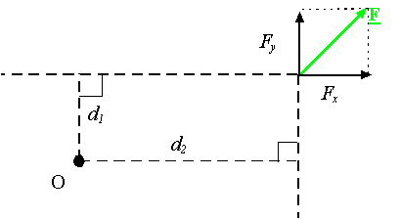
Example:
In the following figure, if θ is 60 degrees and r is 30 mm and F is 6 N, what is the magnitude of the moment about O.
- We choose the CCW as positive direction for moment,
- Component of F along r (or F||) produces no moment, since it passes from point O.
If a force passes through a point, it produces no moment about that point!
- Component of F perpendicular to r (or )
produces the moment .
So the total moment of F about O is:
.
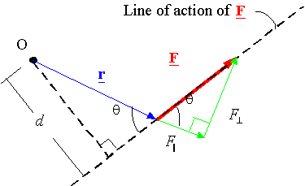
Note: moving a force along its line of action does not change its moment

Remember:
The moment about O is also calculated using the magnitude of force F times perpendicular distance from O to the line of action of F which is d:
.

