Forces and Moments: Part 2
Calculating the moment using rectangular components:
The moment of a force F about the axis passing through point O and perpendicular to the plane containing O and F can be expressed using the cross product:
M_{o} = r x F
The magnitude of the moment is the area shown below:
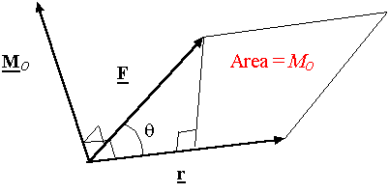
M_{o} = | r x F | = r F sinθ
r = x i + y j + z k
F = F_{x} i + F_{y} j + F_{z`}k
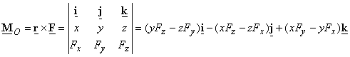
Resultant moment: M_{ro}
