Forces and Moments: Part 3

Moment about an axis:

Sometimes the moment about a point is known and you are supposed to calculate its component about an axis. To find the moment, consider the dot product of M_{o} and unit vector along axis a:
O: any point on a-a
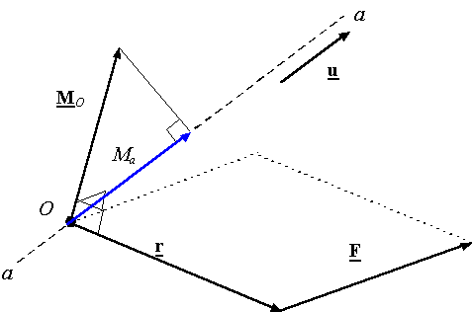
You can also find the tangent force F_{θ} and then r x F_{θ} is the moment about aa:
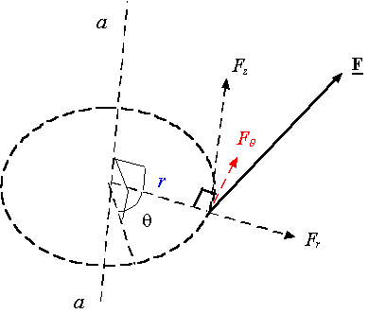

Let us consider the following example:

Force F causes a moment M_{O} about point O. What is the component of M_{O} along axis oy (M_{y})?

Solution:
There are 2 methods to find M_{y}
- Scalar Analysis
- Vector Analysis

(1) Scalar Analysis (first way):
M_{O}=(20)(0.5)=10 N.m
M_{O} tends to turn the pipe around axis ob. The component of M_{O} along the y-axis, M_{y}, tends to unscrew the pipe from the flange at O.
Thus it is important to know its value.
M_{y} = (3/5)(10) = 6 N.m

Scalar Analysis (second way):
To find M_{y} directly (not form M_{O}) it is necessary to determine the moment-arm, knowing that the distance from F to the y-axis is 0.3m:
M_{y} = (20)(0.3) = 6 N.m

In general, If the line of action of a force F is perpendicular to any specific axis aa thus:
M_{a} = F .d_{a}

(2) Vector Analysis:
First, use the cross product formula to calculate the moment about O:
M_{O} = r_{A} × F
M_{O} = (0.3i + 0.4j) × (-20k)
M_{O} = {-8i + 6j} N.m

Then use the dot product of M_{O} and the unit vector along y-axis to get M_{y}:
M_{y} = M_{O} . u_{a}
M_{y} = (-8i + 6j). (j)
M_{y} = 6 N.m

