Problem 1 (Reduction of a distributed load):

Replace the loading by an equivalent resultant force and specify its location on the beam, measured from point B.

Solution:
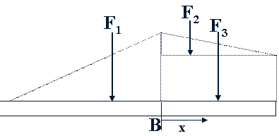

Problem 2 (Reduction of a distributed load):

Replace the loading by an equivalent resultant force and couple moment at point A.

Solution:

Problem 3 (Reduction of a distributed load):

Wet concrete exerts a pressure distribution along the wall of the form. Determine the resultant force of this distribution and specify the height h where the bracing strut should be placed so that it lies through the line of action of the resultant force. The wall has a width of 5 m.

Solution:
Free Body Diagram:
Problem 4 (Reduction of a distributed load):

The lifting force along the wing of a jet aircraft consists of a uniform distribution along AB, and a semi parabolic distribution along BC with origin at B.
Replace this loading by a single resultant force and specify its location measured from point A.
Solution:

FBD:

