Pythagorean Theorem:
a
b
c
θ

a
b
c
βθ
α
γ

The unit circle and trigonometric functions:
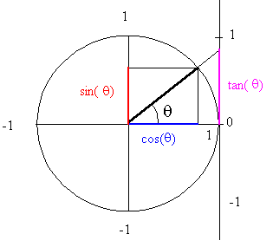
(1)
(2)
(3)
(4)

Double angle relations:

Two angle relations:

Similar triangles:
r
s
θ

The sides of two similar triangles are proportional and the angels are the same. The respective heights of these triangles are also proportional to the sides.

