Dot product:
The dot product of two vectors yields a scalar:
A . B = C

Magnitude:
C = A B cosθ

Cross product:
The cross product of two vectors yields a vector:
A x B = C

Magnitude:
C = A B sinθ

Direction:
Vector C has a direction perpendicular to the plane containing A and B such that C is specified by the right hand rule.

Laws of operations:

The Commutative Law is Not Valid:
A x B B x A
A x B = - B x A

Multiplication by a scalar:
a (A x B) = (aA) x B = A x (aB) = (A x B) a

The Distributive Law:
A x (B + D) = (A x B) + (A x D)
Cartesian Vector Formulation:
C = A x B = (A B sinθ) U_{C}

The magnitude is determined using the formula
C = A B sinθ
Cross products of unit vectors:
The direction is determined using the right hand rule. As shown in the diagram, for this case the direction is k and the Magnitude is:
| i x j |=(1)(1)(sin90°) = (1)(1)(1)=1

so:
i x j = (1) k = k

and:
i x j = k i x k = -j i x i = 0
j x k = i j x i = -k j x j = 0
k x i = j k x j = -i k x k = 0
alphabetical order → +

Cross product of two vectors in terms of their components:
A = A_{x}i + A_{y}j +A_{z}k
B = B_{x}i + B_{y}j + B_{z}k
A x B = (A_{x}i + A_{y}j +A_{z}k) x (B_{x}i + B_{y}j + B_{z}k)

= A_{x}B_{x} ( i x i) + A_{x}B_{y} ( i x j) + A_{x}B_{z} ( i x k)
+ A_{y}B_{x} ( j x i) + A_{y}B_{y} ( j x j) + A_{y}B_{z} ( j x k)
+ A_{z}B_{x} ( k x i) + A_{z}B_{y} ( k x j) + A_{z}B_{z} ( k x k)

= 0 + A_{x}B_{y} k – A_{x}B_{z} j
- A_{y}B_{x} k + 0 + A_{y}B_{z} i
+ A_{z}B_{x} j – A_{z}B_{y} i + 0
Hence:
A x B = (A_{y}B_{z} – A_{z}B_{y} ) i - (A_{x}B_{z} -A_{z}B_{x}) j + (A_{x}B_{y} - A_{y}B_{x} ) k
This equation may also be written in a compact determinant form:
For element i: | (i)(A_{y}B_{z} – A_{z}B_{y} )
For element j: | (-j)(A_{x}B_{z} -A_{z}B_{x})  (notice the negative sign here)
For element k: | (k)(A_{x}B_{y} - A_{y}B_{x} )
Hence:
A x B = (A_{y}B_{z} – A_{z}B_{y} ) i - (A_{x}B_{z} -A_{z}B_{x}) j + (A_{x}B_{y} - A_{y}B_{x} ) k

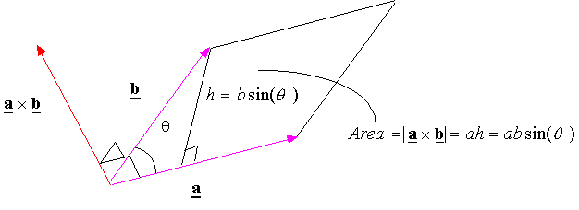
m
In summary, The cross product of vectors a and b is a vector perpendicular to both a and b and has a magnitude equal to area of the parallelogram generated from a and b. The direction of the cross product is given by the right hand rule (fingers from vector a to vector b and thumb is along vector c). Order is important in the cross product:

Triple product:

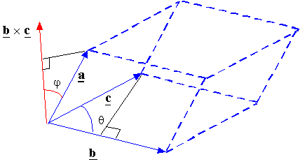

The volume of the parallelepiped constructed from the vectors a, b, and c is given by the triple product of the three vectors:

