Problem 1:
Two smooth pipes each having a mass of 300 kg, are supported by the forks of the tractor, as shown. Draw the free-body diagrams for each pipe and both pipes together.
[Remember to check the first, second and third Newton’s laws]

Solution:
Isolate the object from its surroundings,
Draw the outline of the object; consider all dimensions and angles,

Include all forces and couple moments,
Label known forces and moments with their proper magnitudes and directions,
Unknown forces and moments should be represented with letters.
For pipe A:

For pipe B:
For both pipes:
When pipes A and B are considered as one object, you neglect the reaction forces between them.

Problem 2:

Draw the free-body diagram of the truss that is supported by the cable AB and pin C. Explain the significance of each force acting on the diagram.

Solution:
The FBD is:
Problem 3:

Draw the free-body diagram of the “spanner wrench” subjected to the 20-lb force. The support at A can be considered a pin, and the surface of contact at B is smooth. Explain the significance of each force on the diagram.
Solution:
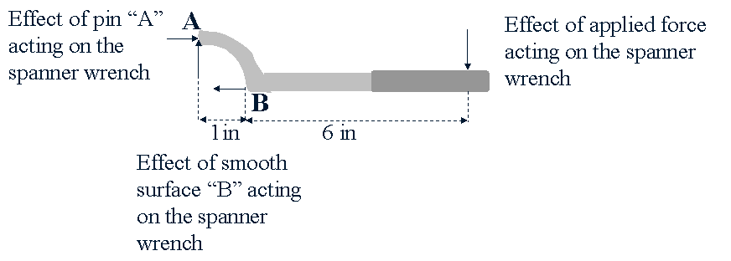
F_{Ax}
F_{Ay}
F_{Bx}
20 lb

