Direction cosines
, ,

Prove:

Solution:
Coordinates of points in space: The triplet (x,y,z) describes the coordinates of a point.

The vector connecting two points: The vector connecting point A to point B is given by
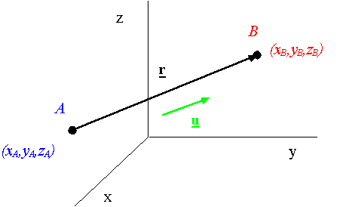

A unit vector along the line A-B: A unit vector along the line A-B is obtained from

