Problem # 3-30
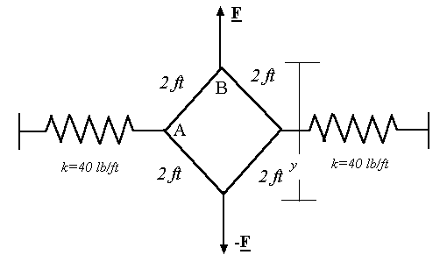
Initial stretch in each spring (y = 0): s_{o}
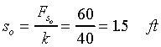
Final stretch in each spring (y = 2 ft): s
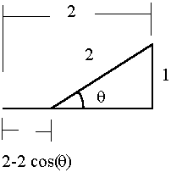
Final load in each spring: F_{s}
Equilibrium for connection at A:
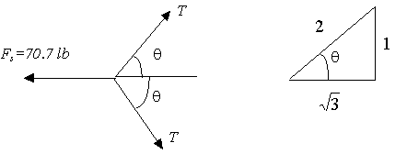
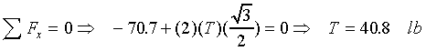
Equilibrium for connection at B:
